5. Project Design Phase
Introduction
The Project Design Phase focuses on defining the structure and user interface of the Streamlining Ticket Assignment for Efficient Support Operations system. During this phase, the system’s database tables, user interface behavior, and security controls are carefully designed to ensure smooth functionality and efficient ticket management.
The design process includes creating structured tables to store ticket information, designing user-friendly interfaces for customers and support agents, and implementing access control mechanisms to protect sensitive data. A well-designed system ensures that users can easily submit, manage, and track support tickets.
This phase also focuses on improving system usability so that both customers and support staff can interact with the system without confusion. Proper design helps improve performance, maintain accurate records, and reduce errors in ticket management.
Table Design
One of the most important tasks in the design phase is creating the Ticket Table, which stores all information related to customer support tickets. Proper table design ensures that the system can manage ticket information efficiently and track the progress of each issue.
The Ticket Table includes several important fields that describe the ticket details, issue category, assigned team, and ticket status.
Key Fields in the Ticket Table
Ticket ID – A unique identification number assigned to each ticket.
Customer Name – The name of the customer who submitted the ticket.
Issue Description – A detailed explanation of the problem reported by the customer.
Category – The type of issue such as Software, Hardware, or Network.
Priority – Indicates the urgency level of the issue.
Assigned Team – The support team responsible for resolving the issue.
Status – Indicates whether the ticket is Open, In Progress, or Resolved.
Example Ticket Table Record:
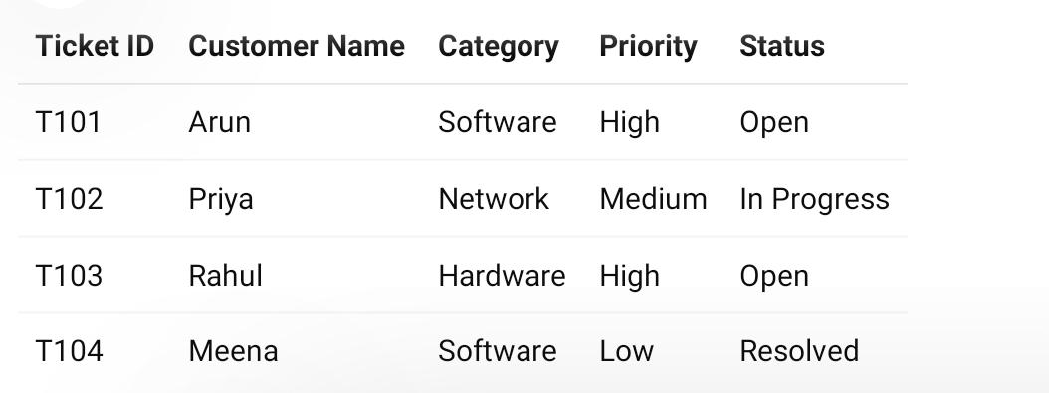

When the ticket is assigned to the support team, the status automatically changes from Open to In Progress.
Example Scenario
Suppose a customer submits a ticket reporting a network connectivity problem. When the ticket is created in the system, the status will initially be set to Open.
The automated ticket assignment system analyzes the issue category and assigns the ticket to the Network Support Team. Once a support agent begins working on the issue, the ticket status is updated to In Progress.
After the problem is resolved, the support agent updates the ticket status to Resolved, indicating that the issue has been successfully handled.
This table design allows the system to easily track support tickets and maintain accurate records of all customer issues.
UI Enhancements
To improve usability and ensure proper data entry, UI Policies are implemented in the system. UI policies control how fields behave on forms based on certain conditions.
In this project, UI policies are used to dynamically change form behavior depending on the ticket status. For example, the Resolution Notes field becomes mandatory only when the ticket status is set to Resolved.
This ensures that support agents provide proper explanations when closing a ticket. It also prevents unnecessary data entry when the ticket is still open or in progress.
Additionally, the user interface is designed to display ticket information clearly through dashboards and forms. Customers can easily create and track their tickets, while support agents can quickly view assigned tickets and update their status.
These UI enhancements improve the overall user experience and ensure efficient ticket management within the system.

